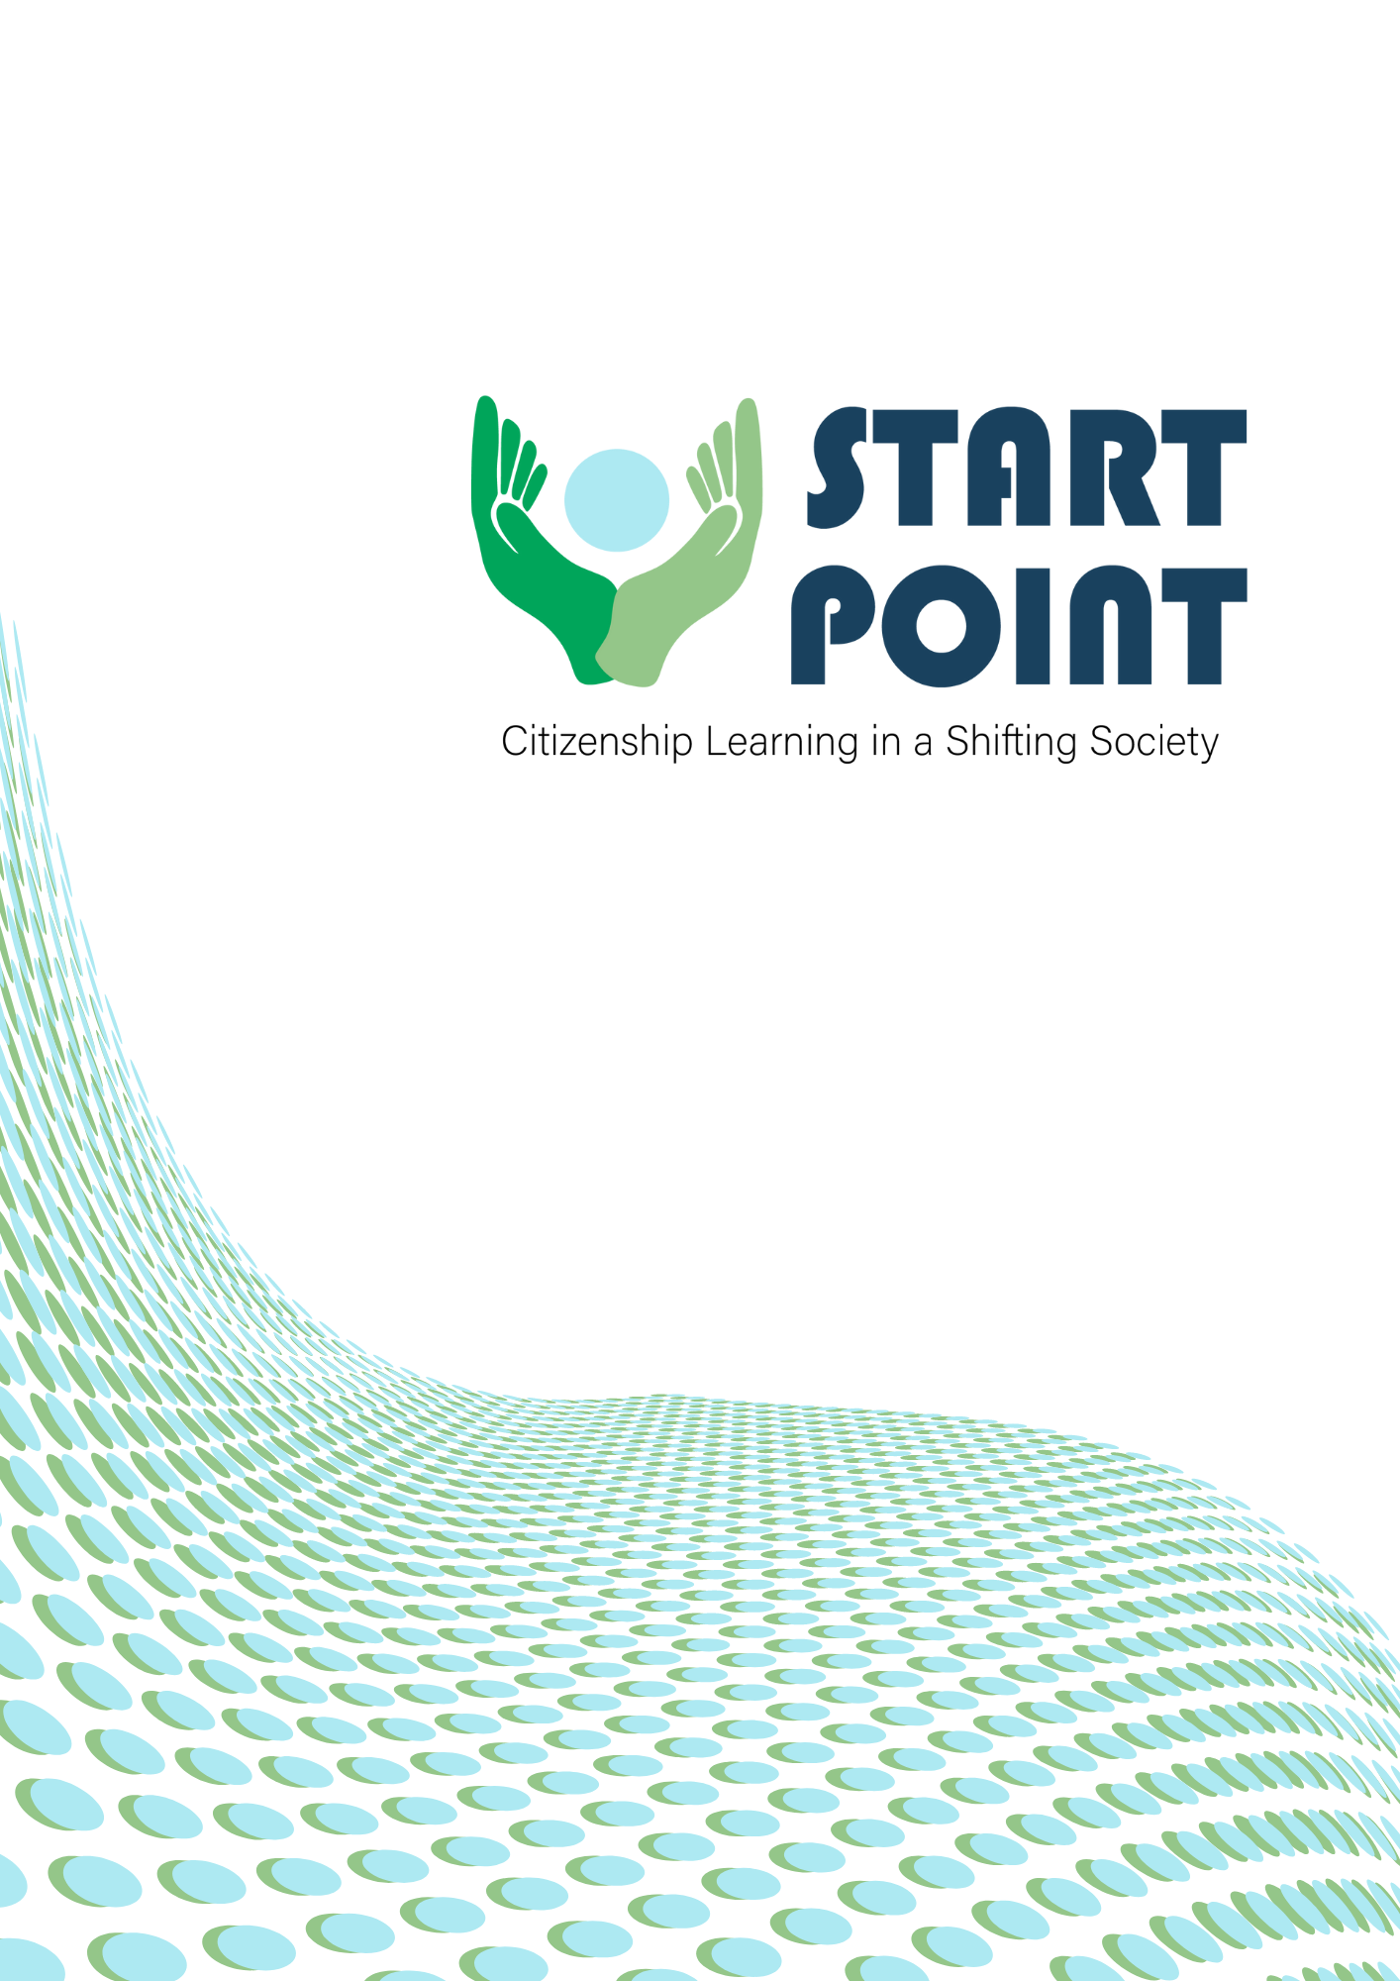
Summary Report
Center for Social Innovation
Introduction:
This is a summary report derived from the 6 Country reports that were drafted in the context of the EU-funded project “StartPoint” (Project no: 2021-1-DE02-KA220-ADU-000026469). The consortium consists of 6 organizations based in 6 EU Countries, KulturLife gGmbH (Germany), CSI CENTRE FOR SOCIAL INNOVATION LTD (Cyprus), Learning for Integration ry (Finland) InterAktion - Verein für ein interkulturelles Zusammenleben (Austria), Rightchallenge - Associação (Portugal), DRUSTVO ZA RAZVIJANJE PROSTOVOLJNEGA DELA NOVO MESTO (Slovenia). We will begin with going through a summary of each country’s findings through the desk and field research conducted during the past few months and then we will draw our overall conclusions. This will help in our pursuit of what the current situation is in our countries of interest, what good practices exist and what are the weak spots we can contribute to. This research will be the foundation for the later parts of the project, which aim in the creation of training material to support the social and political participation of vulnerable young adults in their respective countries.

Slovenia:
When it comes to integration in Slovenia, most initiatives are carried out by NGOs funded by the Republic of Slovenia or the European Commission. There are flaws within the existing system of integration. There is need for stronger coordination and need for inclusion of all relevant stakeholders in the decision-making process when it comes to these topics.

Regarding the survey disseminated in the country, the findings were mixed. Somewhere satisfied with the Target Group’s integration in the social and political life of the country, while others said it could be better. The main obstacles to motivating knowledge and participants were found in the lack of leaders, availability, resources, motivation and educated people. There is also a barrier when it comes to the language and the access of vulnerable people out of the large cities to information and initiatives.

Some recommendations that need to be highlighted from the desk and field research:
- Slovenia needs to create a comprehensive system of support for integration, which will work both ways: offering support to immigrants and the local population.
- Establishment of local coordination in the field of integration, which will include all actors in this field (social work centers, employment services, schools, kindergartens, health centers, employers’ representatives, etc.).
- Extending the entitlement of immigrants to an intensive orientation program by involving local actors in the field of integration.
- Design of adapted Slovenian language learning programs, especially literacy programs, in the form of individual lessons. special vocational guidance programs and adapted vocational education programs (especially in deficit areas).
- Development of education for intercultural mediation at the level of the educational program and inclusion in the national professional qualification.
- Design of community-based programs to support dispersed accommodation opportunities to facilitate the accessibility of integration support instruments.
- Establishment of a mechanism for raising awareness and informing employers as well as strengthening their competencies for intercultural communication.
- Applicants for international protection must be granted faster access to the labour market, from the current nine months to a maximum of three months after applying, in order to give them the opportunity to work legally and to find employment.

Finland:
In Finland, young people in general are interested in politics, even though the methods of participation may vary more nowadays, for example participating in debate in social media has replaced voting as a method of participation to some extent. According to our survey, the main obstacles to promote knowledge and participation to the Target Group are the lack of resources, motivation, training programs and tutors.
Studies show also that education background corresponds with civic and political participation, i.e. those with lower education levels tend to be less active politically. Especially migrant background youth have lower levels of participation than native Finns, but this may also be due to many factors.
There are programmes, practices and projects to increase youth participation in Finland and a lot of information is available online, but they are not very coherent and easily accessible. Migrant organisations are also growing in number in Finland and facilitating civic participation, but they are still small and restricted in resources. It can be difficult for those with lack of language skills and lower education or otherwise coming from disadvantaged backgrounds to access the information and programmes. There is need especially for projects focusing on the needs of these disadvantaged target groups and how to motivate them to become more active.

Germany:
The main factors that seem to deter whether a group tends to participate in its country social and politiical life when it comes to Germany, seem to be the level of education, the income, and the interest in self-realization of the individual. Regarding the exisiting initiatives on integration, the Target Group does not seem to feel addressed or welcome. Young people specifically, do not seem to feel seen by current youth-engagement initiative, as they feel that their reality of life is not reflected adequately. In terms of reccomendations, there needs to be improvement in the ways of engagement and in the attempts of integration. Engagement must become more inclusive and adapted to include young people, considering the variety of social and financial backgrounds. It has been observed that, in Germany, the factor for successful integration is considered to be the alignment of migrants with average societal values in terms of education and occupation. It is important to make clear to these people that the desire to include them is there, that they are being heard and that they are a valuable part of our society.
Survey:
The findings of the survey seem to be affirming the above. Almost half of the responders are not aware of similar initiatives in the country. NGOs and non-profits seem to be taking the lead on initiatives to help our Target Group(TG). The main obstacles seem to be lack of resources, training programmes and tutors that deal with this issue and lack of socialization with the rest of the population of the TG. On recommendations for the future, the majority of responders want to fund new initiatives, which seems to express an overall disappointment with how things are going and the existing solutions.

Austria:
According to MIPEX, Austria’s policies create more obstacles than opportunities for the integration of non-EU migrant population into the Austrian society.

Austria’s approach is classified by MIPEX as “temporary integration” because non-European migrants benefit from basic rights and support for equal opportunities, but they do not receive support and security for permanent settling. This approach is also encouraging the Austrian population to see immigrants as foreigners and not as equals.

Austria’s MIPEX score is lower than the European average, scoring 46 from 100 points and being the most insecure country from all 56 MIPEX countries alongside Switzerland and Denmark.
From the 8 points analyzed by MIPEX (Labour market mobility, Family reunification, Education, Health, Political participation, Permanent residence, Access to nationality, Anti-discrimination) the most favorable scored the Health sector, where immigrants have the same conditions as the natives as long as they have their status recognized and have the national health insurance. At the same time, the health information is presented in various migrant languages and on different formats, making it accessible across the big majority of migrant population, but intercultural mediators are too few. On the other side, the fields that scored the lowest are Political Participation and Access to nationality. Migrants are not allowed to vote, and immigrant associations have very low support. Immigrants’ eligibility for Austrian citizenship is still very unfavorable because of very strict naturalisation requirements such as language, good character, income and costs, as well as Austria not allowing double citizenship.

Portugal:
Despite some evidence that democratic participation among the younger generations is decreasing, it’s more likely that the way they participate is simply changing. According to different data, young people have been developing an interest in democratic participation through online means, volunteering, campaigns, petitions, and activism. Although, the rates of participation in democratic society is not as low as one might have expected, it’s very clear that young people from disadvantaged backgrounds find many more barriers to active participation.

The existing good practices that promote citizenship learning and democratic participation such as The National Strategy on Citizenship Education, The National Plan on Democratic Literacy, Participatory Budget for Youth are less accessible to the target group. Cultural, language, economic, and geographical aspects can significantly inhibit their ability to fully participate in democratic life.

The results of the audit survey have revealed that there is lack of agreement regarding if the target group members have access to civic and social participation or not. Furthermore, the majority of the participants weren’t aware of any initiatives or good practices promoting young people participation. This shows the need to develop and implement initiatives that reach young disadvantaged adults and truly give them the opportunity and tools to be active citizens in society.

Cyprus:
There seems to be an overall hesitancy to change and leaving old practices behind. Education on social and political life seems to be heavily targeted on children and younger students than adults and even less specifically targeted on vulnerable adults. Overall, there is not a strong culture of adult learning in Cyprus. The protagonist of efforts to help the target group seems to be NGOs and Nonprofits. There is need to update education curriculum for adults and encourage a culture of learning.
While there are some good practices pointed out in academic sources and in the survey, there is plenty of room for improvement. Everyone involved in these types of initiatives, form teachers to trainers, to representatives of stakeholders need diversity training and understanding the multidimensional vulnerabilities that the TG tends to face.
The main barriers that the target group is facing seem to have to do with isolation from the main population through lack of access to technology, language and resources. While plenty of participants managed to point out quite a few good practices, there seems to be an overwhelming need for innovation and inclusion. there seems to be no space or platform for the demographic to voice their concerns, let alone be included in the conversation as everyone else.

Conclusions:
Taking into consideration the findings of the consortium, we can draw the following conclusions and adopt the following recommendations:
- The main issues across the board seem to be lack of resources, the language barrier and the accessibility in terms of location.
- NGOs and non-profits appear on the forefront of initiatives relating to the topic of this project.
- There needs to be stronger effort for systemic, governmental change.
- The TG, especially young people, do not feel represented or taken into consideration through most of the existing initiatives.
- The recommendations seem to be favoring innovation and funding new initiatives.
- The Target Group does not have the basic elements needed to succeed; there is need for language classes, accessibility in all forms and inclusion of all stakeholders in the initiatives meant for the TG.
- A culture of life-long learning should be encouraged further, especially when it comes to civil and political life.

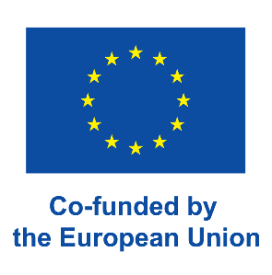
The European Commission's support for the production of this publication does not constitute an endorsement of the contents, which reflect the views only of the authors, and the Commission cannot be held responsible for any use which may be made of the information contained therein.
Project no. 2021-1-DE02-KA220-ADU-000026469

The content of this reports stems from the national reports conducted in the context of the Erasmus+ project StartPoint. The sources of information include, but are not limited to, academic articles, books, newspapers, reports conducted by national or international authorities as well as a survey designed for this project specifically. All sources are listed in each national report.

